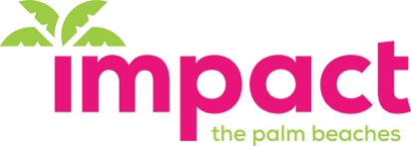
Women Leading Efficient Collaborative Philanthropy
FAQ’s

Our Mission: We are a dynamic leader of women’s philanthropy: bringing new resources to the community and making philanthropy accessible. Through strategic high-impact grant making, we engage, develop and inspire women to create change in our community.

Serving central and northern Palm Beach County community through high impact grants to local nonprofits. Members contribute $1,000, which is pooled together to fund grants of $100,000. Each year at the annual meeting, nonprofit finalists are invited to speak, Impact 100 members vote, and funds are awarded.

About Us:

- Impact 100 the Palm Beaches is a simple commitment to efficient and effective philanthropy.
- Membership is open to any woman with a contribution of $1,100
- There are 5 grant focus areas: Arts/Culture, Education, Environment, Family, and Health/Wellness. Nonprofits apply online.
- Impact 100 Palm Beaches is supported by the Town of Palm Beach United Way as our fiscal agent.

Geographic Area of Focus: Grants will be awarded to non-profit organizations serving the following communities: Lake Worth Road north to the Palm Beach County line - East to the Island & West to the Glades. Including the communities of: Lake Worth, Wellington, Belle Glade, Pahokee, West Palm Beach, Palm Beach, North Palm, Palm Beach Gardens, Jupiter & Tequesta

Membership Invitation

- Commit to an annual contribution of $1,100:
($ 1,000 grant award pool; $100 annual meeting & operational overhead)

Membership Responsibilities:

- Become a Member (because you like to be a part of great new ideas).
- Attend the annual grant-making meeting (be a part of giving away transformational $100,000 grants) and if you are feeling ambitious and have the time, you can participate in site visits to help us narrow down the organizations we are presenting to members for grant consideration.
- Be the change you wish to see in the world and invite others to join us.

For Additional Information: www.ImpactPalmBeaches.org

